W205 summer 2017 section 2 – Lab09 - K Iwasaki

1. *What is the shortest path between 'DR. STRANGE/STEPHEN' and 'DR. DOOM/VICTOR VON'?*

**Query and Result**

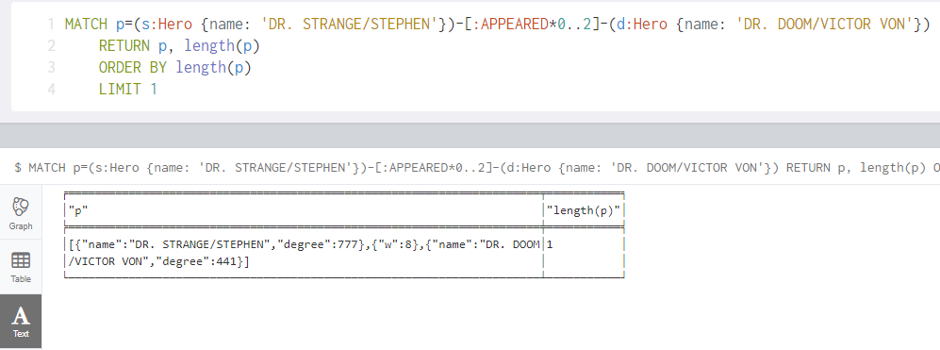

**Answer:** The shortest path is length 1 between DR. STRANGE and DR. DOOM.

1. *List the 5 shortest paths between 'DR. STRANGE/STEPHEN' and 'DR. DOOM/VICTOR VON'.*

**Query and Result**

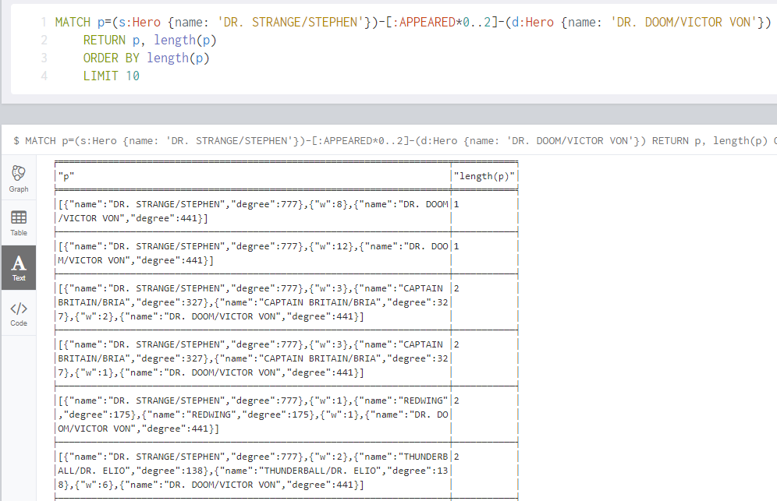

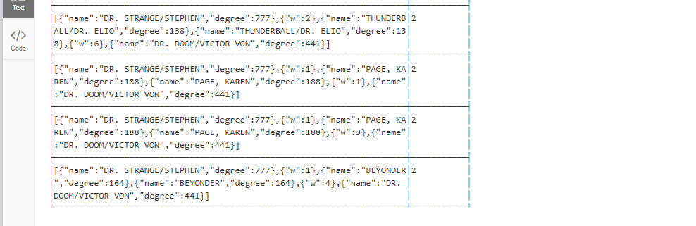

**Answer:**

1. *'DR. STRANGE/STEPHEN'* and *'DR. DOOM/VICTOR VON' are* connected directly (length1)

2. They are connected through "CAPTAIN BRITAIN/BRIA" (length2)

3. They are connected through "REDWING" (length2)

4. They are connected through "THUNDERBALL/DR. ELIO" (length2)

5. They are connected through "PAGE, KAREN" (length2)

1. *List 5 Friends of Friends of 'COLOSSUS II/PETER RA' with the most connections.*

**Query and Result**

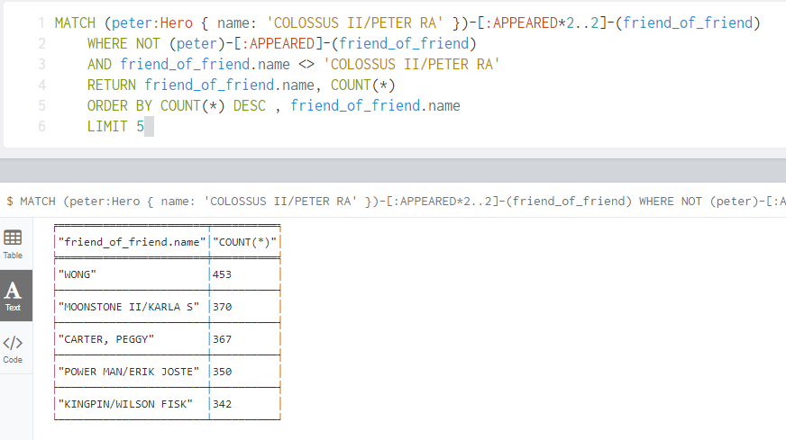

1. *Visualize 10 Friends of friends for 'IRON MAN/TONY STARK'.*

**Query and Result**

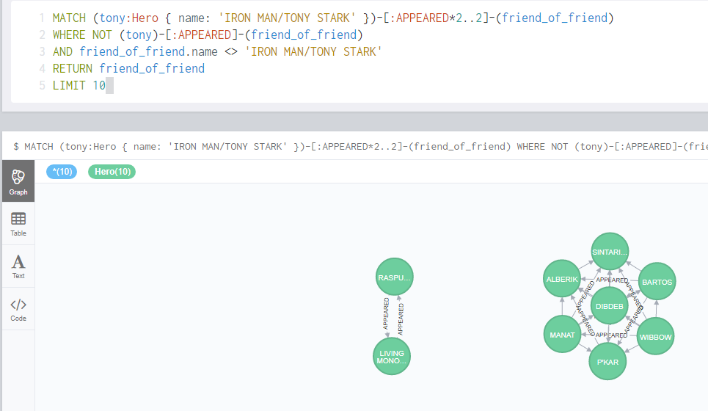

1. *Visually discover how the Avengers grew over time from 5 to 10 members, who was added to the team, and verify connectivity.*

**LIMIT of 3 to return 5 members: The graph is fully connected**

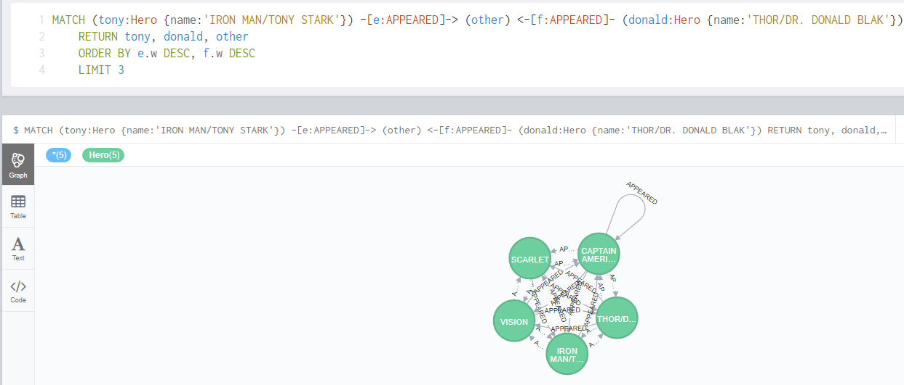

**LIMIT of 4 to return 6 members: The graph is fully connected**

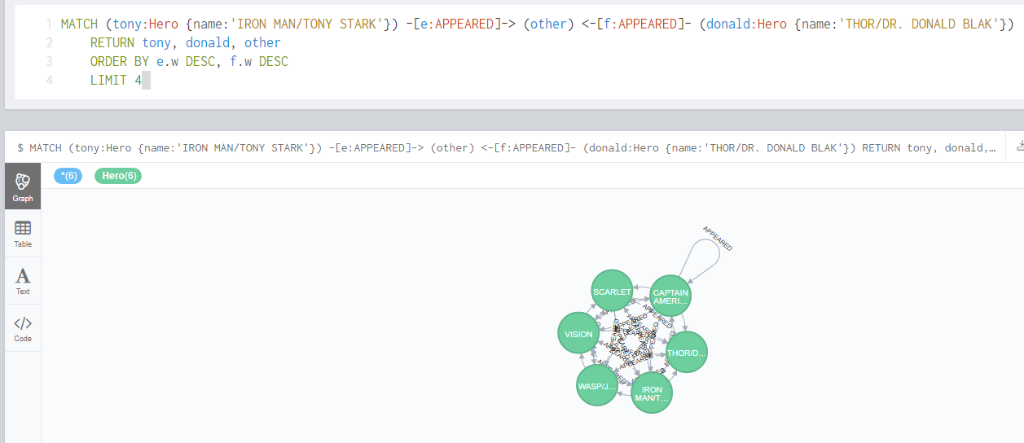

**LIMIT of 5 to return 7 members: The graph is fully connected**

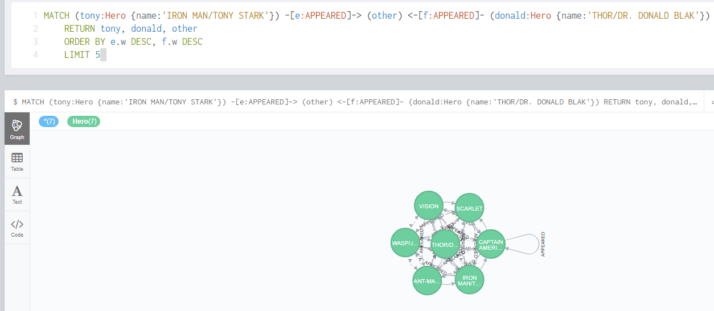

**LIMIT of 6 to return 8 members: The graph is fully connected**

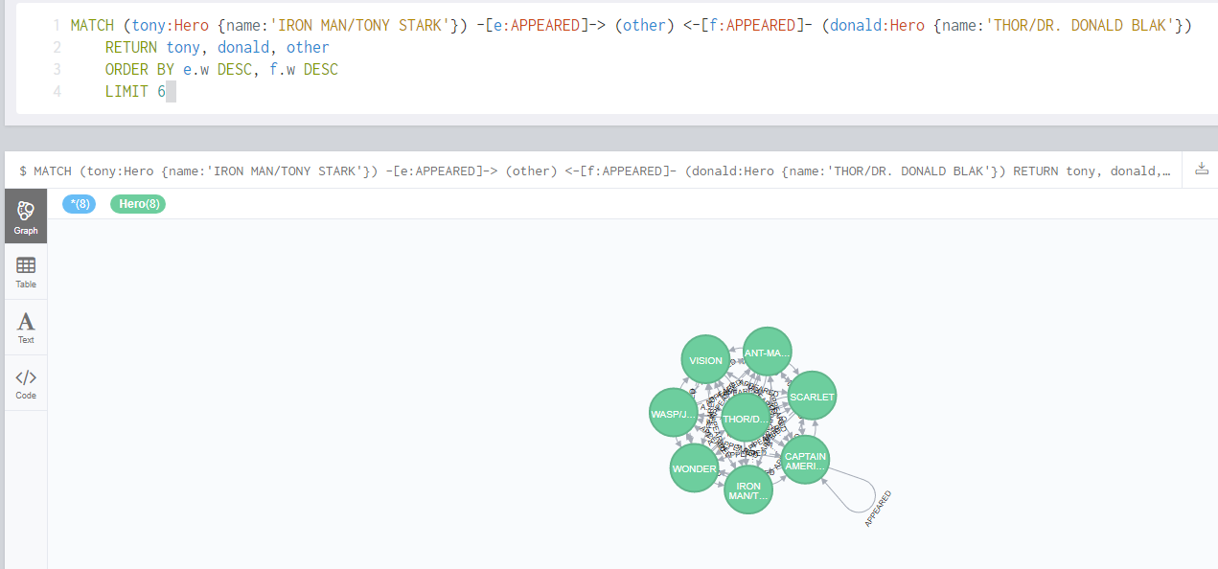

**LIMIT of 7 to return 9 members: The graph is fully connected**

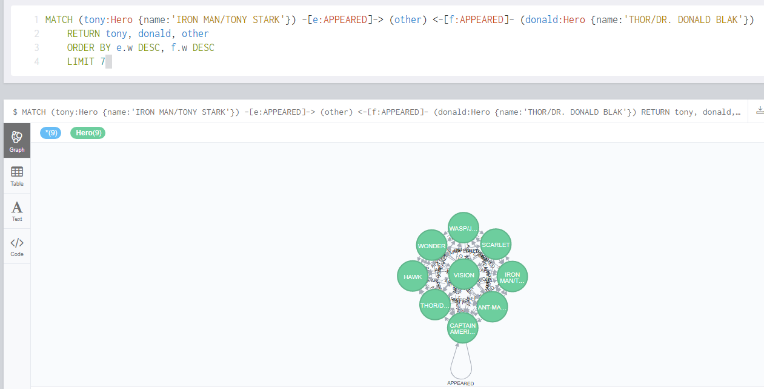

**LIMIT of 8 to return 10 members: The graph is fully connected**

